9

Some pupils are asked to make the circuit shown in this circuit diagram.

Here are five of the circuits they make. For each, put a tick () in one box to show if you think the pupil has made a circuit which matches the diagram.

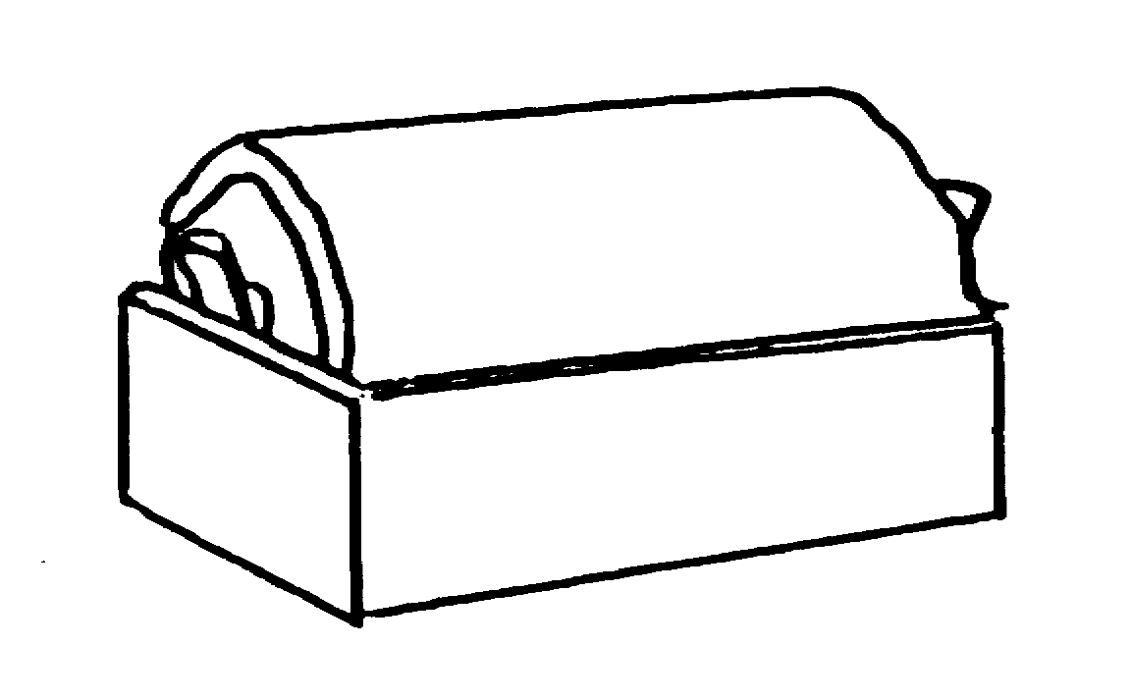
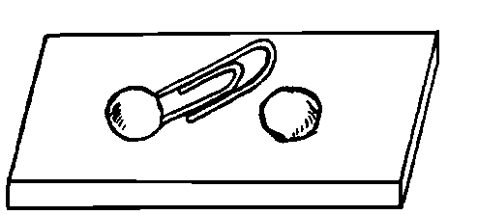
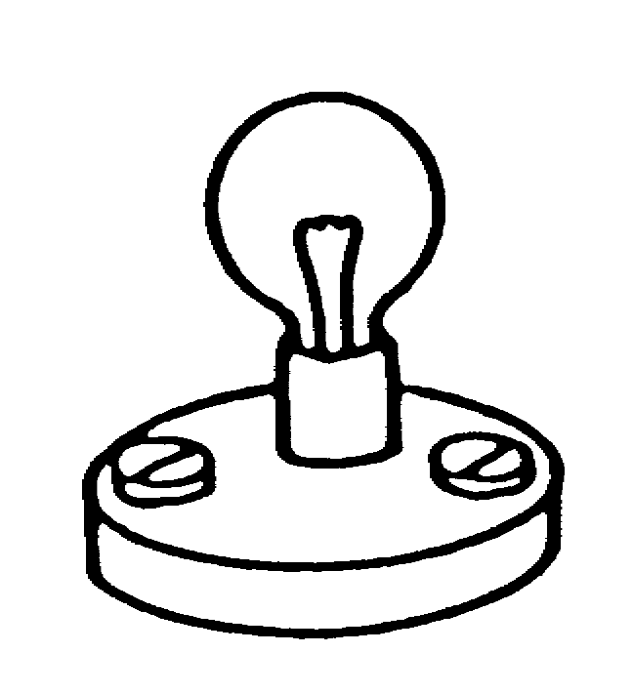
a. b.
.

wrong
correct
.

wrong
correct
.

wrong
correct
.

wrong
correct
.

wrong
correct

c. d.

e.

